TITLE OF THESIS (Times New Roman, 14 pt., bold, center, single space, UPPERCASE)
CZU:
DOI:
Author’s NAME SURNAME (centered, 12 pt., bold, UPPERCASE)
Institution (centered, 12 pt.)
e-mail (centered, 12 pt.)
ORCID ID: (16-digit number, e.g.: 0000-0002-7982-4567) (centered, 12 pt.)
Please follow the requested format of the essay /paper template. Structure: Abstract, Keywords (max. 6), JEL Classification, Introduction, Main Content (which can be divided into paragraphs), Conclusions, References. The total length should not exceed 4 pages. For the main text, use A4 pages (21 x 29 cm) with 2 cm margins on the top, bottom, left, and right, Times New Roman font, 12 pt., line spacing 1.15, full justification (left and right alignment). The titles of the main sections should be written in uppercase and highlighted in bold, aligned to the left, with 6 pt spacing before and after the titles. The first line of each paragraph should be indented by 1 cm. Any paper that does not comply with the format may be rejected.
The deadline for submitting papers for review is MARCH 25, 2025.
Abstract. The abstract must be written in English. This section should briefly present the essential results described in the thesis: research topic, research questions, methods used, results obtained, data analysis, and conclusions. Your abstract should be approximately between 100 and 200 words. Format: Times New Roman, 11 pt., line spacing 1.15, justified alignment.
Keywords: Select 4-6 key terms (words or phrases) that capture the essence of the paper. List them in descending order of significance. Separate terms with commas and use Times New Roman, 12 pt., written in English.
JEL Classification: For JEL Classification, use Times New Roman, 12 pt. Access JEL Classification System for reference.
INTRODUCTION
The introduction specifies the importance of the chosen topic, describes the problem investigated within the context of already published studies, and presents relevant results that familiarize the reader with the research. The introduction should conclude by stating the aim and, if necessary, the objectives of the paper. In this section, critically review relevant articles related to your research topic/question. The review should include:
- The research question posed by the authors
- Theories used
- Stated research hypothesis
- Significance of the study
All citations must be listed in the references section. There should be no discrepancy between citations and references. Use the MLA citation style (Refer to this guide).
In-text citations should appear in parentheses, including the surname and page number. Full references must be listed alphabetically at the end of the paper. When citing a work with three or more authors, use the format (Main Author et al. page), e.g., (Georgescu et al. 42). Online citations should include the access date. If a source has no author, use the title in italics, followed by the page number(s), e.g., (“How to Write a Research Paper” 8). Include an abbreviated version of the title in the in-text citation if you cite multiple works by the same author, e.g., (Georgescu, “The Future with AI” 22).
MAIN CONTENT
The research content should be described in detail. It may be divided into paragraphs. Each paragraph title should be left-aligned, indented by 1 cm, and preceded by an ordinal number. Arabic numerals should be used for numbering. The spacing before the title should be 6 pt.
- Materials and Methods
The research materials and methods must be described in detail to ensure the credibility of the analyzed results. Indicate key sources (initial studies) where the applied method was first mentioned, as well as any variations from standard methods.
- Results and Discussion
Results should be presented logically, in relation to materials and methods. All study results should be presented in accordance with the proposed objectives. Results are to be displayed in tables, figures, etc., referenced in the text. Illustrative material should be numbered and accompanied by a title, clearly and concisely described, and include the source. When discussing results, distinguish between your own findings and those from other research (which should be cited properly). Also, highlight the novelty of your study, its contributions, and its impact on the advancement of knowledge.
- Formatting Figures
All figures should be numbered sequentially and accompanied by a title, such as Figure 1. The title should be in Times New Roman, 12 pt., placed below each figure. All figures must be referenced in the text. The spacing before and after figures should be 6 pt. All figures must have a source (even if it is your own work, it must be mentioned), in Times New Roman, 11 pt., Italic.
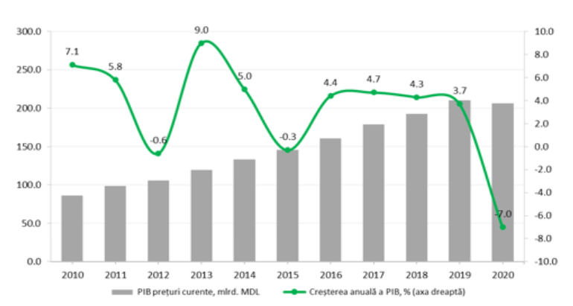
Figure 1. Trends in GDP Growth.
Source: National Bureau of Statistics.

- Formatting Tables
All tables should be numbered sequentially and titled, such as Table 1. The title should be Times New Roman, 12 pt., centered above each table. All tables must be referenced in the text. The spacing before and after tables should be 6 pt. All tables must have a source, in Times New Roman, 11 pt., Italic.
Table 1. Current R&D Expenditures by Scientific Fields,
in Million Lei, 2022.
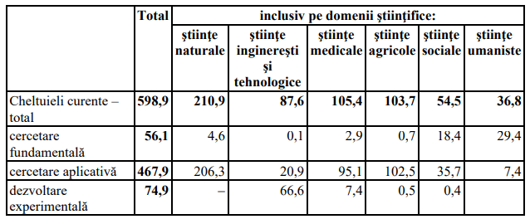
Source: Extracted from ("DECISION on Approving the National Program for Research and Innovation 2024-2027 No. 1049 of 21.12.2023" 4).
- Inserting Formulas
Formulas should be written using MS Word Equation Editor. Displayed equations should be right-aligned and numbered in parentheses using Arabic numerals. There should be 6 pt. spacing above and below the equation to separate it from the surrounding text.
$ϕ_{i}\left(G\right)=\frac{1}{\left|N\right|!}\sum_{πϵΠ_{N}}{Δ_{π}^{G}\left(i\right)}$ (1)
CONCLUSIONS
Conclusions interpret the obtained results in the form of scientifically based statements, presented clearly and concisely. They should highlight:
- The significance, novelty, and originality of the results
- The potential for further research in the field
- Study limitations and future research directions
- Unexpected results and those that contradict similar studies
REFERENCES
The complete list of references should be placed at the end of the paper, alphabetically ordered, using Times New Roman, 11 pt.
Examples:
Single-author book: Redman, P. Good Essay Writing: A Social Sciences Guide. 3rd ed. London: Sage, 2006.
Book with multiple authors (three or more): Adams, R.J., et al. The World Health Organization, Its History and Impact. London: Perseus, 2010.
Book chapter in a monograph: Samson, C. Problems of Information Studies in History. In: S. Stone, ed. Humanities Information Research. Sheffield: CRUS, 1970, pp. 44-68.
Journal article: Boughton, J.M. "The Bretton Woods Proposal." Political Science Quarterly, 42(6), 2002, pp. 564-578.
Web source: Tsutomu, S. "Japan’s Transformation: A New Dawn in the Land of the Rising Sun?" Financial Times, June 12, 2023. Available at: https://www.ft.com/partnercontent/societe-generale/japans-transformation-a-new-dawn-in-the-land-of-the-rising-sun.html [Accessed 09.01.2025].

